**SPH3U: Review Package**

**Unit 1**

* 1. **Distance, position, and displacement**

Imagine that you are going to visit your friend. Before you get there, you decide to stop at the variety store. If you walk 200 m [N] from your home to the store, and then travel 600 m [S] to your friend’s house, what is your total displacement?

* 1. **Speed and velocity**

On a windy day, the position of a balloon changes as it is blown 82 m [N] away from a child in 15 s. What is the average velocity of the balloon?

A subway train travels at an average velocity of 22.3 km/h [W]. How long will it take for the subway train to undergo a displacement of 241 m [W]?

* 1. **Acceleration**

When a hockey player hits a hockey puck with his stick, the velocity of the puck changes from 8.0 m/s [N] to 10.0 m/s [S] over a time interval of 0.050 s. What is the acceleration of the puck?

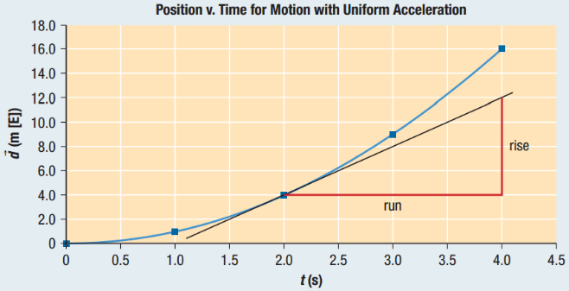Consider the point on the curve in the figure above at 2.0 s on the ­*x*-axis. Using the graph to the right, what is the instantaneous velocity at 2.0 s?

What is the average velocity over the time interval from 0.0 s to 2.0 s?

* 1. **Comparing graphs of linear motion**

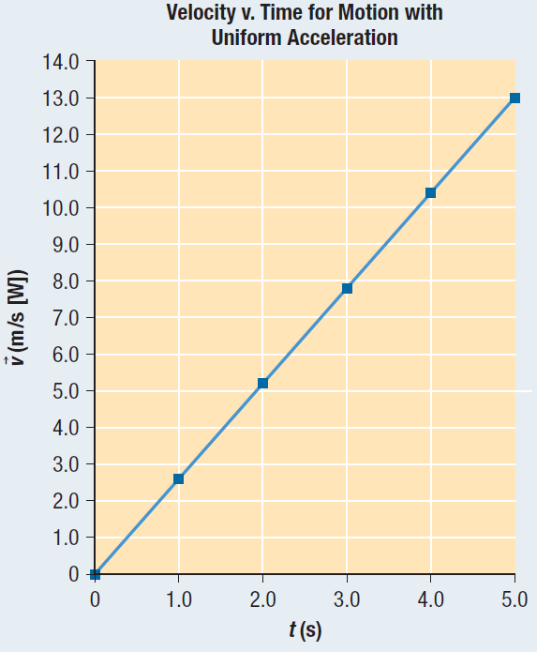Use the velocity-time graph shown to the right to sketch the corresponding position-time graph and acceleration-time graph. Assume that the initial position of the object is 0.

* 1. **Five key equations**

A sports car approaches a highway on-ramp at a velocity of 20.0 m/s [E]. If the car accelerates at a rate of 3.2 m/s2 [E] for 5.0 s, what is the displacement of the car?

A dart is thrown at a target that is supported by a wooden backstop. It strikes the backstop with an initial velocity of 350 m/s [E]. The dart comes to rest in 0.0050 s.

1. What is the acceleration of the dart?
2. How far does the dart penetrate into the backstop?
   1. **Acceleration near Earth’s surface**

A flowerpot is knocked off a window ledge and accelerates uniformly to the ground. If the window ledge is 10.0 m above the ground and there is no air resistance, how long does it take the flowerpot to reach the ground?

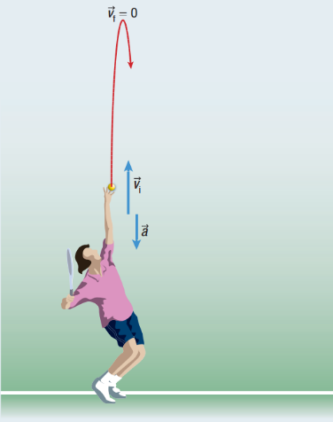A tennis ball is thrown straight up in the air, leaving the person’s hand with an initial velocity of 3.0 m/s, as shown to the right. How high, from where it was thrown, does the ball go?

* 1. **Motion in two dimensions – Scale diagrams**

While in a race, a sailboat travels a displacement of 40 m [N]. The boat then changes direction and travels a displacement of 60 m [S30°W]. What is the boat’s total displacement? Use a scale diagram to solve.

* 1. **Motion in two dimensions – Algebra**

A hockey puck travels a displacement of 4.2 m [S38°W]. It is then struck by a hockey player’s stick and undergoes a displacement of 2.7 m [E25°N]. What is the puck’s total displacement?

* 1. **Projectile motion**

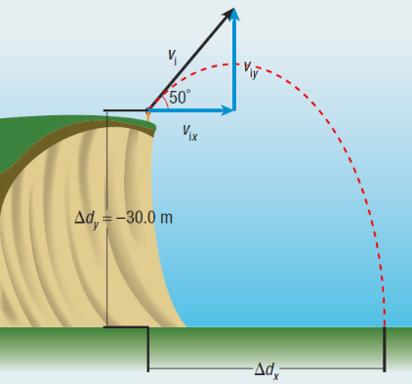A golfer is trying to improve the range of her shot. To do so she drives a golf ball from the top of a steep cliff, 30.0 m above the ground where the ball will land. If the ball has an initial velocity of 25 m/s and is launched at an angle of 50° above the horizontal, determine the ball’s time of flight and its range.